REPL ASSIGNMENT

USN: 1MS24SCS30

EXAMPLE 1:

const readline = require("readline").createInterface({

  input: process.stdin,

  output: process.stdout,

});

readline.question("Enter numbers separated by commas: ", (input) => {

  const numbers = input.split(",").map(Number);

  console.log("Iterating through the numbers:");

  for (const num of numbers) {

    console.log(num);

  }

  readline.close();

});

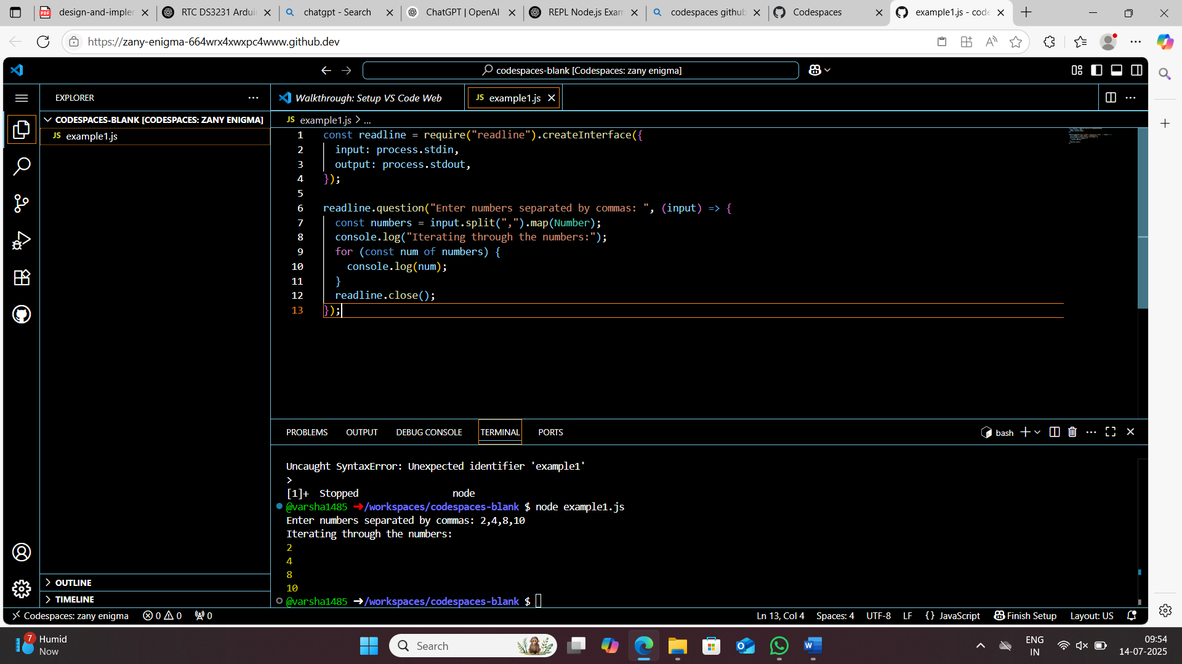

EXAMPLE 2:

const readline = require("readline").createInterface({

input: process.stdin,

output: process.stdout,

});

let data = [];

readline.question("How many items do you want to enter? ", (count) => {

let n = parseInt(count);

let index = 0;

function askInput() {

if (index < n) {

readline.question(`Enter item ${index + 1}: `, (item) => {

data.push(item);

index++;

askInput();

});

} else {

console.log("\nYou entered:");

for (let i = 0; i < data.length; i++) {

console.log(`Item ${i}: ${data[i]}`);

}

readline.close();

}

}

askInput();

});

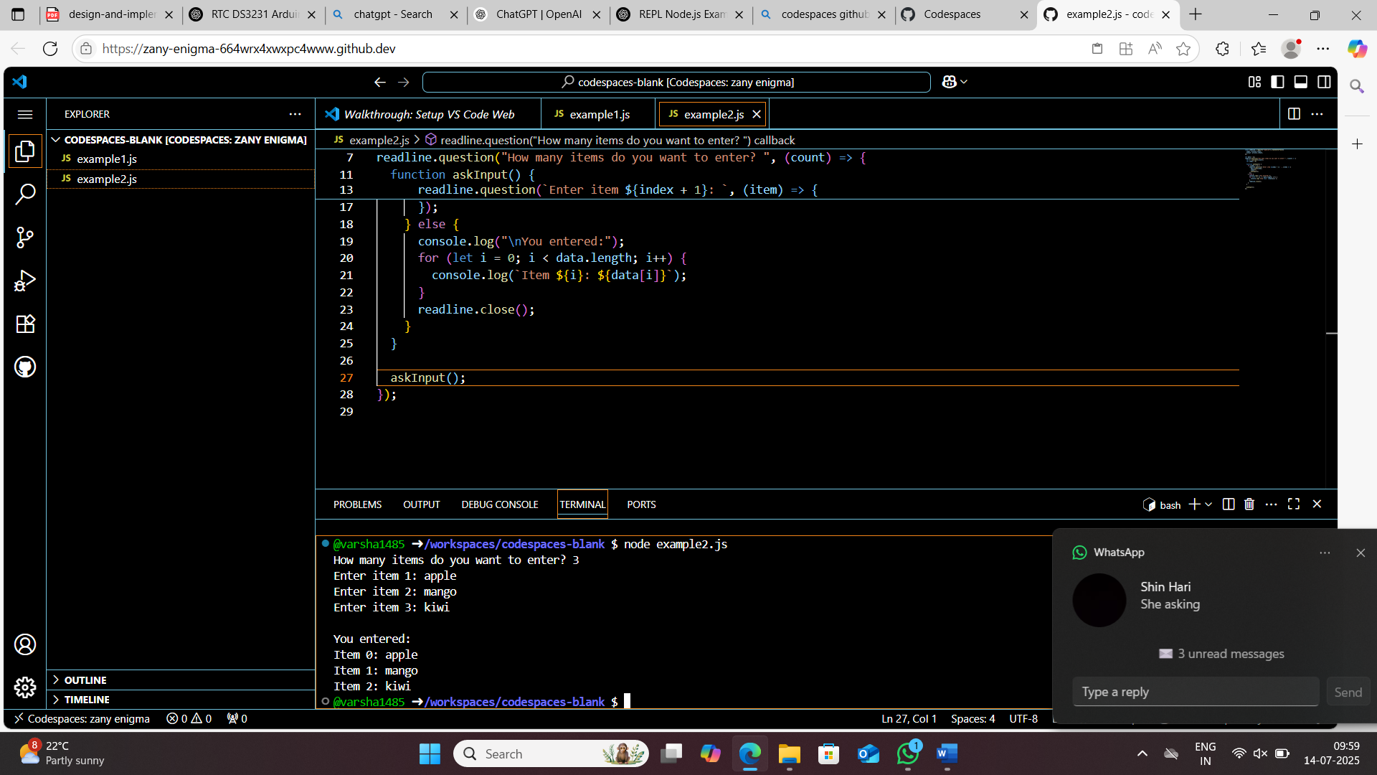

EXAMPLE 3:

const readline = require("readline").createInterface({

input: process.stdin,

output: process.stdout,

});

readline.question("Enter integers separated by spaces: ", (input) => {

const arr = input.trim().split(" ").map(Number);

const evens = [];

for (let i = 0; i < arr.length; i++) {

if (arr[i] % 2 === 0) {

evens.push(arr[i]);

}

}

console.log("Even numbers are:", evens);

readline.close();

});

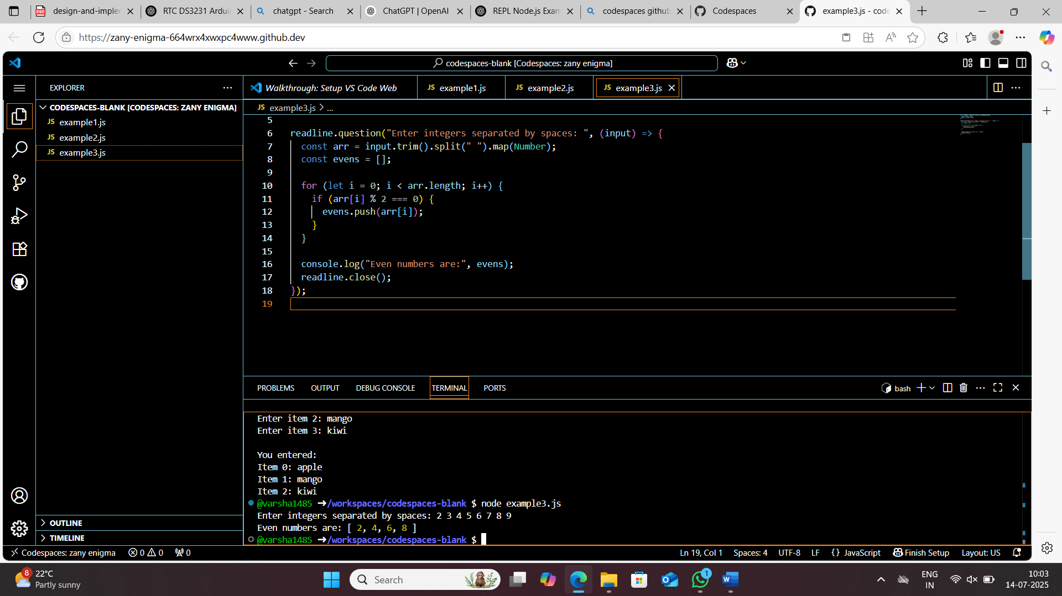

EXAMPLE 4:

const readline = require("readline").createInterface({

input: process.stdin,

output: process.stdout,

});

readline.question("Enter some words separated by space: ", (input) => {

const words = input.split(" ");

const vowels = "aeiouAEIOU";

for (const word of words) {

let count = 0;

for (const ch of word) {

if (vowels.includes(ch)) count++;

}

console.log(`'${word}' has ${count} vowels.`);

}

readline.close();

});

